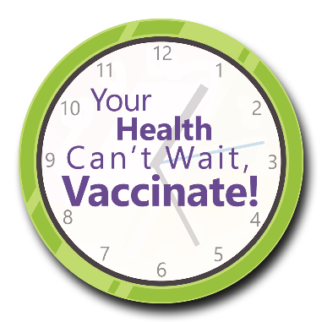

**Your Health Can’t Wait, Vaccinate!**

*Stakeholder Newsletter Article*

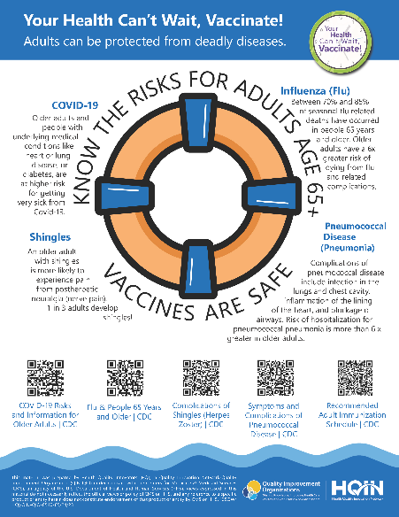**Vaccination Campaign Encourages Everyone to Put Their Health First**

To promote and increase adult vaccinations, and celebrate August as National Immunization month, Health Quality Innovators (HQI) has launched the *Your Health Can’t Wait, Vaccinate!* campaign.

As the CMS-designated Quality Innovation Network-Quality Improvement Organization for Missouri, HQI collaborates with healthcare providers and community partners to improve the quality of healthcare in our region.

Want to help spread the information to prevent unnecessary illness, hospitalizations and worse outcomes? Visit the HQIN Resource Center to access the [free campaign materials](https://hqin.org/resource/your-health-cant-wait-vaccinate-resources/), which include social media messaging (images and sample posts), informational pocket cards, customizable letters, sample email signatures and flyers.