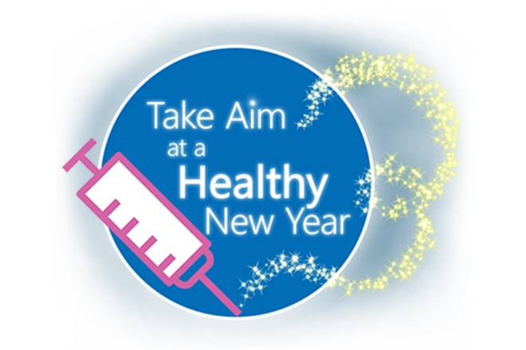
COVID-19 Vaccine Encouragement Email Signatures

The following statements can be customized to your organization and added to staff email signatures, newsletters and mailers.
- You are encouraged to take your bivalent booster immunization now if you have not already. It is the best option for protecting yourself and others from COVID-19. View the 1-minute COVID Boosters video.

- <Insert Organization Name> encourages everyone to keep up to date with immunizations. Don’t forget that you can take more than one vaccine at a time and get twice the protection at one visit. View the 1-minute COVID Boosters video and education on bivalent booster vaccinations.

- COVID-19 vaccinations are the best, safest way to protect against severe illness, hospitalization and death. Learn why.

- Is it the flu or COVID? Now’s the time to get vaccinated for both. This flyer explains.

- Data continue to show that COVID-19 vaccines are safe & effective. Get vaccinated as soon as you can and get a booster shot when eligible. Find your vaccine.
This material was prepared by Health Quality Innovators (HQI), a Quality Innovation Network-Quality Improvement Organization (QIN-QIO) under contract with the Centers for Medicare & Medicaid Services (CMS), an agency of the U.S. Department of Health and Human Services (HHS). Views expressed in this material do not necessarily reflect the official views or policy of CMS or HHS, and any reference to a specific product or entity herein does not constitute endorsement of that product or entity by CMS or HHS. 12SOW/HQI/QIN-QIO-0389-12/21/22

