Offerings Support Group
for Covid-19 related Grief & loss
Ramanda.Brockett@moshowmehope.org  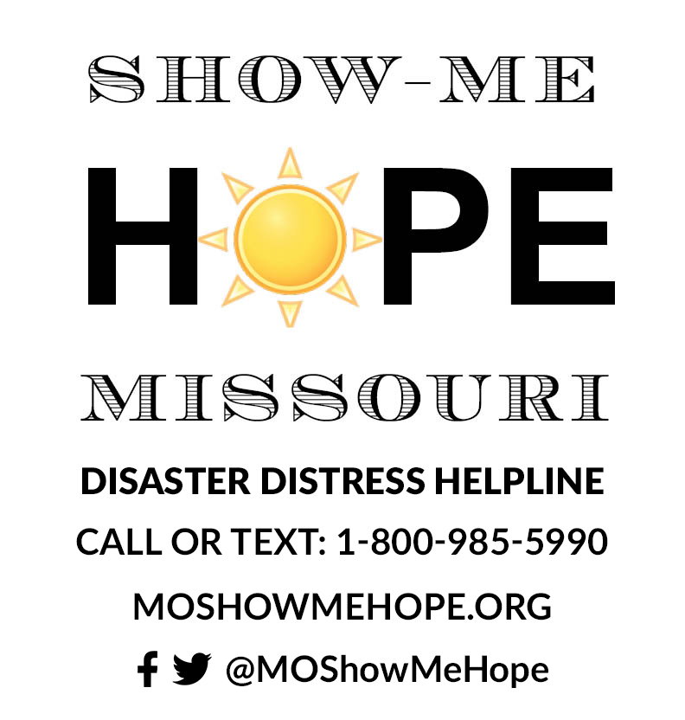 | This is a FREE virtual support group for friends, family, and care team members who have experienced Covid-19 related grief and loss. We will meet weekly for 6 one-hour sessions and draw from mindfulness, expressive therapies, and solution-focused therapy techniques to guide our discussion in support of each other.
 | Click the link to register  https://covid19supportgroup.eventbrite.com | Tuesdays @4:30pm  Begins Tuesday, January 19th

