MISSOURI HEALTHCARE COALITIONS
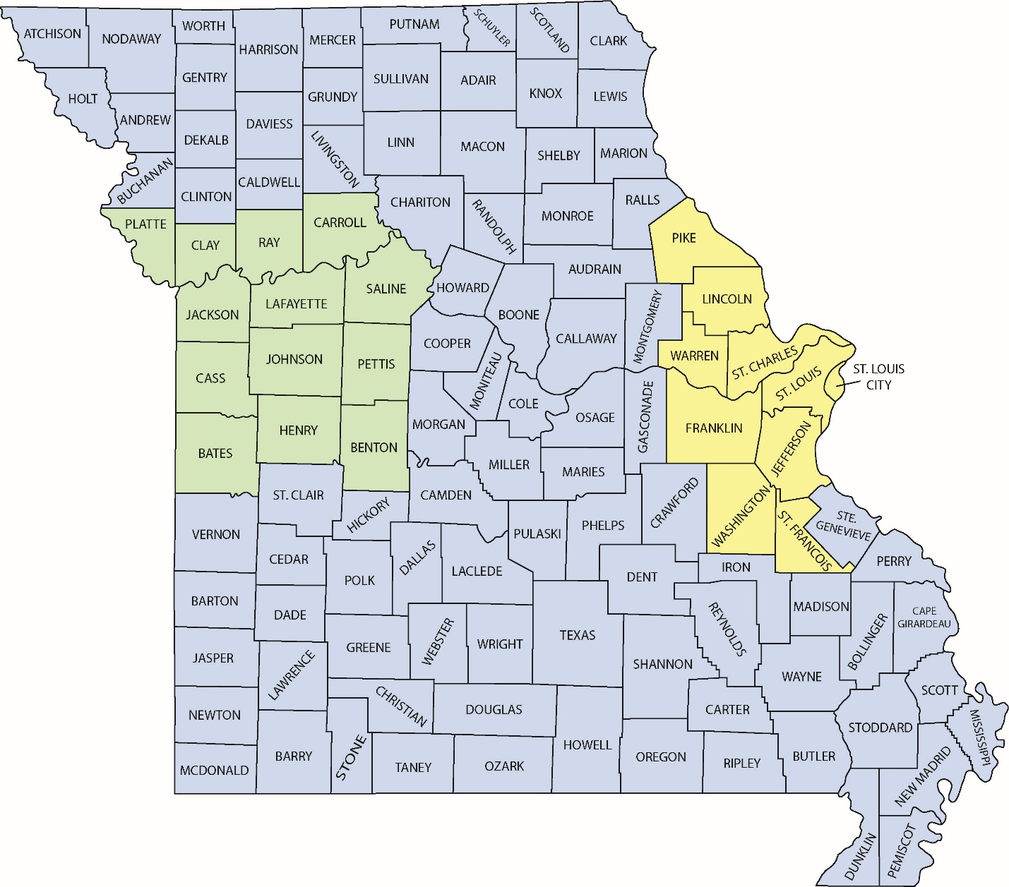

Healthcare Coalition (HCC) Contacts
Region A | Non-Urban Rural | Region C
Jennifer Sutherlin  Mid-America Regional Council  jsutherlin@marc.org  816-474-4240 | Jackie Gatz  Missouri Hospital Association jgatz@mhanet.com  573-893-3700 | Brad Zoref  St. Louis Area Regional Response System  Brad.Zoref@ewgateway.org  314-421-4220

Region A Healthcare Coalition  (MARC) |  |  | Region C Healthcare Coalition  (STARRS) | Non-Urban Healthcare Coalition  (MHA)
Metro | Northern District | Southern District |  | Sub -Region B | Sub-Region F | Sub-Region H | Southeast  Sub-Region | Southwest  Sub-Region
CASS | CARROLL | BATES | FRANKLIN | ADAIR | AUDRAIN | ANDREW | BOLLINGER | BARRY
CLAY | LAFAYETTE | BENTON | JEFFERSON | CHARITON | BOONE | ATCHISON | BUTLER | BARTON
JACKSON | RAY | HENRY | LINCOLN | CLARK | CALLAWAY | BUCHANAN | CALDWELL | CARTER
PLATTE | SALINE | JOHNSON | PIKE | KNOX | CAMDEN | CLINTON | CAPE GIRARDEAU | CEDAR
 |  | PETTIS | ST CHARLES | LEWIS | COLE | DAVIESS | DUNKLIN | CHRISTIAN
 |  |  | ST FRANCOIS | LINN | COOPER | DEKALB | IRON | CRAWFORD
 |  |  | ST LOUIS | MACON | GASCONADE | GENTRY | MADISON | DADE
 |  |  | ST LOUIS CITY | MARION | HOWARD | GRUNDY | MISSISSIPPI | DALLAS
 |  |  | WARREN | MONROE | MILLER | HARRISON | NEW MADRID | DENT
 |  |  | WASHINGTON | PUTNAM | MONITEAU | HOLT | PEMISCOT | DOUGLAS
 |  |  |  | RALLS | MONTGOMERY | LIVINGSTON | PERRY | GREENE
 |  |  |  | RANDOLPH | MORGAN | MERCER | RIPLEY | HICKORY
 |  |  |  | SCHUYLER | OSAGE | NODAWAY | SCOTT | HOWELL
 |  |  |  | SCOTLAND |  | WORTH | STE GENEVIEVE | JASPER
 |  |  |  | SHELBY |  |  | STODDARD | LACLEDE
 |  |  |  | SULLIVAN |  |  | WAYNE | LAWRENCE
 |  |  |  |  |  |  |  | MARIES
 |  |  |  |  |  |  |  | MCDONALD
 |  |  |  |  |  |  |  | NEWTON
 |  |  |  |  |  |  |  | OREGON
 |  |  |  |  |  |  |  | OZARK
 |  |  |  |  |  |  |  | PHELPS
 |  |  |  |  |  |  |  | POLK
 |  |  |  |  |  |  |  | PULASKI
 |  |  |  |  |  |  |  | REYNOLDS
 |  |  |  |  |  |  |  | SHANNON
 |  |  |  |  |  |  |  | ST CLAIR
 |  |  |  |  |  |  |  | STONE
 |  |  |  |  |  |  |  | TANEY
 |  |  |  |  |  |  |  | TEXAS
 |  |  |  |  |  |  |  | VERNON
 |  |  |  |  |  |  |  | WEBSTER
 |  |  |  |  |  |  |  | WRIGHT

